DANSO MACHINERY LTD

ROH ROTAVATORS

ORIGINAL INSTRUCTIONS

ROH 125/150/180/200

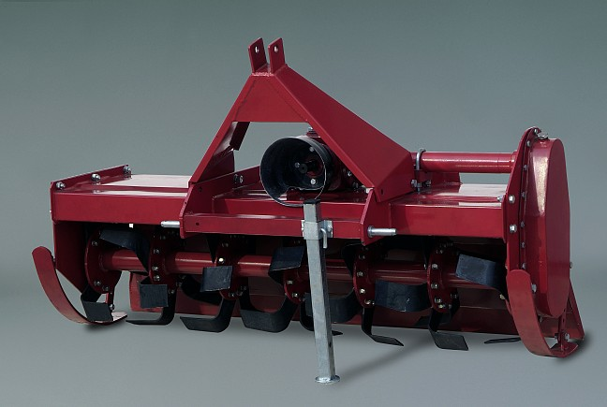
Ryland Business Park, Bunclody, Co.Wexford
(053) 9376660 (087) 9186042

Safety information
Safety at all times
Throughly read and understand the instructions given in this manual before operation. Refer to the “Safety Decal”, read all instructions noted on them.
- Operator should be familiar with all functions of the unit.
- Operate implement from the driver’s seat only.
- Make sure all guards and shiekds are in place and secured before operating the implement.
- Do not leave tractor or implement unattended with engine running.
- Dismounting from a moving tractor could cause serious injury or death.
- Do not stand between tractor and implement during hitching.
- Keep hands, feet, and clothing away from power-driven parts.
- Wear snug fitting clothing to avoid entanglement with moving parts.
- Watch out for wires, trees, etc., when raising implement. Make sure all persons are clear of working area.
- Turning tractor too tight may cause implement to ride up on wheels. This could result in injury or equipment damage.
Be aware of signal words
A signal word designates a degree or level of hazard seriousness. The signal words are:
! DANGER
Indicates an imminently hazardous situation which, if not avoids, will result in death or serious injury. This signal word is limited to the most extreme situations, typically for machine components that, for functional purpose, cannot be guarded.
! WARNING
Indicates a potentially hazardous situation which, if not avoided, could result in death or serious injury, and includes hazards that are exposed when grards are removed. It may also be used to alert against unsafe practices.
! CAUTION
Indicates a potentially hazardous situation which, if not avoided, may result in minor or moderate injury. It may also be used to alert against unsafe practices.
For you protection
- Thoroughly read and understand the “safety label” section, read all instructions noted on them.
Shtutdown and storage
- Lower machine to ground, put tractor in park, turn off engine, and remove the ignition key.
- Detach and store implements in a area where children normally do not play. Secure implement by using blocks and supports.
Use safety lights and devices
- Slow moving tractors, self-propelled equipment, and towed implements can create a hazard when driven on public roads. They are difficult to see, especially at night.
- Flashing warning lights and turn signals are recommended whenever driving on public roads.
Transport machiery safely
- Comply with state and local laws.
- Maximum transport speed for implement is 20 mph. Do not exceed. Never travel at a speed which does not allow adequate control of steering and stopping. Some rough terrain require a slower speed.
- Sudden braking can cause a towed load to swerve and upset. Reduce speed if towed load is not equipped with brakes.
- Do not tow a load that is more than double the weitht of tractor.
Keep riders off machinery
- Riders bostruct of operator’s view, they could be struck by forein objects or thrown from the machine.
- Never allow children to operate equipment.
Practice safe maintenance
- Understand procedure before doing work. Use proper tools and equipment.
- Work in a clean dry area.
- Lower the implement to the ground, put tractor in park, turn off engine, and remove key before performing maintenance.
- Allow implement to cool completely.
- Do not grease or oil implement while it is operation.
- Inspect all parts. Make sure parts are in good condition and installed properly.
- Remove buildup of grease, oil or debris.
- Remove all tools and unused parts from implement before operation.
Prepare for emergencies
- Be prepared if a fire starts.
- Keep a fist aid kit and fire extinguisher handy.
- Keep emergency numbers for doctor, ambulance, hospital and fire department near phone.
Wear protective equipment
- Protective clothing and equipment should be worn.
- Wear clothing and equipment appropriate for the job. Avoid loose fitting clothing.
- Prolonged exposure to loud noise can cause hearing impairment or hearing loss. Wear suitable hearing protection such as earmuffs or earplugs.
- Operating equipment safely requires the full attention of the operator. Avoid wearing radio headphones while operating machinery.
Avoid high pressure fluids hazard
- Escaping fluid under pressure can penetrate the skin causing serious injury.
- Avoid the hazard by relieving pressure before disconnecting hydraulic lines.
- Use a piece of paper or cardboard, not body parts, to check for suspected leaks. Wear protective gloves and safety glasses or goggles when working with hydraulic systems.
- If an accident occurs, see a doctor immediately. Any fluid injected into the skin must be treated within a few hours or gangrene may result.

Structure and their adjustment
These series rotary tillers are tillage equipment by means of the compound motion both of the rotation of the blade and the tractor going forward. Each rotary consists of transmission sets and working parts. Transmission sets include driveline, gearbox, side chain box (gearbox). Working parts include blade and blade shaft. Headstock, the cover and trailing bar are assistant sets (Fig.1).
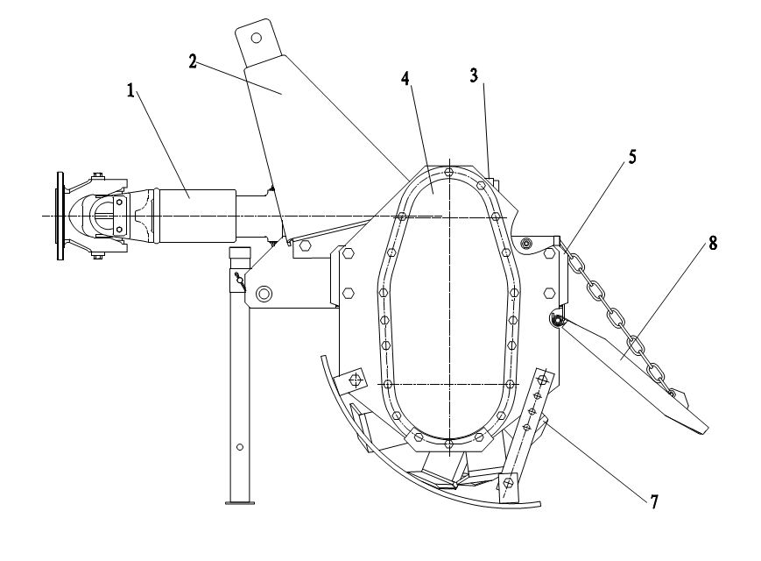
1-universal coupling 2-headstock 3-gearbox 4-side chain(gear)box 5.right side plate 6-cover 7-blade shaft 8-trailing bar

Safety labels

Specification
These series rotary tiller, are driven by the power-take –off of tractor. it is a kind of excellent equipment for primary and secondary tillage . it can match with 18.4-44.1kw(25-60HP)wheel-tractor, working on unplowed and plowed field , surface soil smooth ,good coverage with weed and stubble , working depth uniform , efficiency high . it can get the results of multi-ply plowing by one times tilling . it is suitable for plowing in dry field and paddy field in the area of producing wheat and rice .These series rotary tiller have 1GL105/125/135/150, 1GN180/200/230/250H, 1GKN180/200/230/250. Being adopted helical bevel gears meshing for main shift gears in the gearbox, whole structure , whole cover and forced trailing bar ,they are good rigidity , stable operation , low noise , high efficiency , low oil consume and easy to maintain ,etc. the ratio of breaking clod reaches above 95% .
Model | ROH125 | ROH150 | ROH180 | ROH200
Dimensions (L*W*H cm) | 152x83x107 | 175*83*107 | 205x83x107 | 225X83X107
Structure weight (kg) | 400 | 430 | 460 | 490
Working width (cm) | 130 | 155 | 180 | 205
Number of flanges | 5 | 6 | 7 | 8
Number of blades per flange | 6
Hitch type | Standard 3-point hitch
Gearbox lubrication | SAE 90 oil
Rotor diameter | 18"
Rotor shaft speed | 214 rpm at 540 rpm PTO
Tractor power (KW) | 18-35 | 35-45 | 45-55 | 55-65

Driveline assy
The driveline consists of universal joint head, universal joint head for male shaft, the universal joint head for female shaft and joint cross. there are rings on the both ends of joint cross to avoid the movement of joint cross, and there is also a grease hole on the joint cross and the needle bearing can be well lubricated if you inject grease into it frequently. The universal joint head for male shaft and the universal joint head for female shaft are sliding joint and it can be pulled back and forth freely when the rotary tiller rises or falls. It must be noted that the interval between socket and shaft is in the shortest situation but the socket and the shaft can not contact each other during operating, and if the interval between the socket and the shaft is in the biggest situation, the overlap of socket and shaft must be longer or equal to the 1/2 length of the shaft.
Headstock
The upper hitch point on the headstock must be connected with the control link of the tractor and the lower coupling pin of headstock must be connected with the tension link of the tractor to make the rotary tiller form the stable three-point hitch linkage.
Central gearbox assy
The central gearbox assy consists of gearbox front cap, rear cap, first shaft, second shaft and a helical bevel gear pair that transmits the power to side chain box. There is an oil hole for adding oil on the top of the gearbox. And there is a plug for draining oil at the bottom of the gearbox. The helical bevel gear is splined matches the shaft .The gears are tightened with elastic collar, washer and locknut to prevent axial moving.
In using, the bearing clearance and the gear backlash will be changed because of wearing of bearings and gears, so you must adjust them (if necessary).
Adjustment of helical bevel gear backlash:
A proper backlash is the one of the condition for working normally. If the backlash is too large, it will result in the strong collision and loud noise.
Precaution:
Helical bevel gear backlash must be adjusted after the clearance of bearing on the first shaft has been adjusted. For retaining the clearance of bearing in which have been adjusted, for pinion, the total thickness of adjusted shims of the front and the hind bearing seat on the first shaft must keep up. For example, when moving the pinion forward, the decrease –the adjusted shims of the hind –bearing seat on the first shaft must be added to the front bearing seat on the first shaft, vice versa. For large helical bevel gear, when moving it rightward, you must decrease the shims of the bearing seat of the large bevel gear.
In general, just move the pinion forward when you do it.
Adjustment of the bearing axial clearance on the second shaft
When the axial displacement was occurred very distinctly on the second shaft, you must adjust it in time as following steps: first, loosen washer and screw down the lock nut, then adjusts the displacement of the bearing on the second shaft until there was no distinct axial movement and easy to rotate the shaft.
Finally, lock the jam nut with the washer. This prevents the bearing from loosing.
Side chain(gear)box assy
The side chain box consists of chain box, two chain wheels, chain tension units, second shaft and left side plate assy. Adjustment of the chain: Loosen and screw down the adjustable screw to adjust the tension of the chain, keep the right tension. In general, it can be pressed down 10 mm at another side of chain.
The side gearbox consists of side gearbox, three shafts and left side plate assy.
Right side plate assy
The right side plate assy consists of right side plate, right head of cultivator shaft, right side bearing and bearing seat.
Cover assy
A specific purpose of the cover is warding off clod, safeguarding the driver and still farther breaking the clod.
When rotary tiller is working, if the gap between the blade edge and the cover is too large ,the clod would be thrown to the front of the cultivator shaft, so that it will be cultivated once more, therefore the power of the tractor will be wasted; if the gap is too small, it is easy to congest, recommend gap is 30-45 mm.
Cultivator shaft assy
The cultivator shaft assy consists of cultivator shaft, blade disc and blade.
Trailing bar
The function of the trailing bar is still farther breaking the clod and flatting the cultivated land. It was connected with cover. You can obtain different effect of land surface by adjusting the height of the trailing bar. In general, if the soil is dry, to set lower, if the soil is wet, to set higher. When you remove the mud and the weed on the cultivator shaft, assemble the blades, long-distance transport; you should set the bar at the highest.
Methods of operating
Installation of headstock with the main body
Before being put in the container, the equipment is parted with the main body. The users refer to Fig.1,
simply to fix it on the main body with the bolts in the affix pouch. Pay attention to fitting the spring washers on the bolts, and fastening them firmly.
The methods of blade mounting
To meet the requirement of agricultural technique, the blades are adopted different fixing methods, so that a variety of tillage effects can be gotten. Blades should avoid mounting in reverse and making the back of the blades enter into soil, the parts will be damaged because of overload.
The left-bent blades and the right-bent blades work in a stagger state on whole blade shaft. Only a blade enters into soil at the same time. this arrangement is suitable to flat plowing, so the blade shaft operates stable; the surface of plowed field is smooth. To extend the application scope, every type of rotary tillers has tow sort of blade arrangement. Type 125and type 135 have 20 blades or 30 blades; type 150 has 24 blades or 36 blades, type 1780 has 28 blades or 42 blades. Please take a strictly attention to mounting the blades according to the mark on the blade discs.
Connecting with the three-point linkage of tractor
The connecting way of rotary tiller with the tractor is three-point linkage. The steps are as follows:
- Align the center of headstock by reversing the tractor, raise the link arm to appropriate height, reverse the tractor to make the link arm of tractor joint with the left and right pin of rotary tiller.
- first install the left lower linkage arm, then install right lower linkage arm, (because the leveling lift rod has screw that can be adjusted length.)finally insert the pins.
- install the upper linkage arm, and then insert the pin.
- mount the driveline, and then insert the pins, poke the cotter pin.
It must be taken attention to mounting order of the universal coupling.
Adjustment before working
1. Adjustment of horizontal level
Put it down to make the blade tips near the ground, observe that the height between the right and left blade tips and the ground is same or not. If not, it is necessary that the right linkage arm of tractor be adjusted to level off the blade shaft, which ensures the uniformity of working depth.
2.Adjustment of longitudinal level
Fall the tiller to tillage depth desired, observe that universal coupling and PTO shaft are level or not.
If the angle of universal coupling is too large, adjust the control link to make it nearly level, which can maintain that universal coupling and the tiller work in the good condition.
Cultivating route
When working in a piece of larger land, in land plowing is adopted to reduce the empty time in turn land, to raise work efficiency. The width of the plot selected is whole number multiple of the working width or near as possible, so as to decrease repeat tilling. The width of the plot is commonly 15m or so, if too wide, the empty time in turn land will be longer, the efficiency be less, the repeat times of idle motion be more, the mud depth be longer. The flat tillage in the medium and small fields refer to the in land plowing.
Starting of the tiller
First,filling with gear oil in the gearbox and the side chain box, injecting grease to the crosshead and the bearing seat of the blade shaft. Then check for the looseness of all connecting bolts and nuts, if loosing, fastening it at once. If the crack and deforming are found in the blades,they must be replaced.
Starting tractor: rise the tiller and the blade tip must be away from ground 150mm-200mm, and joint universal coupling, then run in 1-2 minutes, gear the operating gear position and increase the fuel throttle , control the leveling handle to make the tiller enter into the soil gradually until the normal tillage depth at the same time.
Selecting of forward speed
The selecting principle of tiller forward speed: the tractor cannot overload constantly; the performance of breaking soil meet the needs of agriculture requirement, furrow bottom and the soil surface are smooth. Not only be tillage quality ensured, but also the rated power of tractor be made good use of, and the purpose of rising work efficiency must be attained.
Generally, rotary tilling directly:2km/h-5km/h,harrowing:5km/h-7km/h;if the unit draft of the soil is bigger, can select lower gear; contrarily select higher gear; when working in dry fields, select lower gear; when working in paddy fields, select higher gear.
Operating of headstock
- Using position control when the tiller works. The handle of draft control must be put in the position marked”up”.
- When the handle of position control moves forward, the tiller fall down; contrarily the tiller rise.
- After the tiller reaching to required depth, using the position hand-wheel to block it, in favor of that the tiller falls the same depth every time.
- The details refer to the instruction of matching tractor.

DRIVELINE DIMENSION
A PTO driveline is supplied with the machine. To ac-company the variety of 3 point hitch geometry available today, the driveline can be too long for most machines or too short for others. It is very important that the drive- line be free to telescope but not to bottom out when going through its working range. If the driveline bottoms out, the bearings on both the machine and tractor PTO shaft will be overloaded and fail in a short time.

1. To determine the proper length of the driveline, follow this procedure:
a. Clear the area of bystanders, especially small children.
b. Attach the chipper to the tractor (see section), but do not attach the driveline.
c. Raise the machine until the input shaft is level with the tractor PTO shaft.
d. Measure the dimension between the locking grooves on the tractor PTO shaft and the machine input shaft.
e. Measure the same dimensions on the compressed driveline.
f. If the compressed driveline dimension exceeds the machine dimension, the driveline will have to be cut.
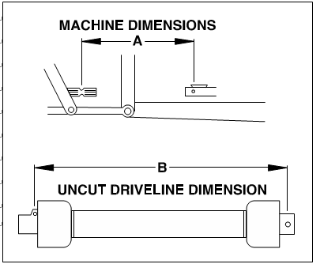

2. When cutting the driveline, follow this procedure:
a. Subtract the machine dimension (A) from the uncut driveline dimension (B) or (B-A). This dimension determines how much too long the driveline is.
b. Add another inch (25 mm) to the dimension to be sure it doesn't bottom out, to determine (C) the cut off dimension.
c. Use a hacksaw to cut dimension (C) from both ends. Cut both the plastic tubes and the metal cores.
d. Use a file to remove the burrs from the edges that were cut.
e. Assemble the 2 ends of the shaft.
f. Make sure the shaft can telescope freely. If it does not, separate the 2 parts and inspect for burrs or cuttings on the shaft ends. Be sure it telescopes freely before installing.
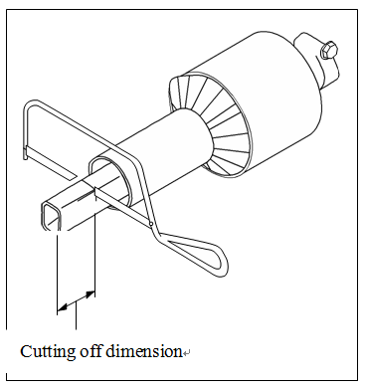

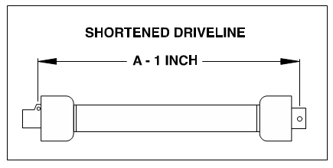

Maintenance
To ensure that the tiller woks properly, higher efficiency and prolonging the serve life, it is important that maintenance must be done properly.
Daily maintenance (after 10 hours operating)
- Check, tighten up all of the joint bolts and nuts, tighten them up or replace them if necessary.
- Check the lubricant oil in the gearbox and the side chain (gear) box, keep the oil level desired.
- Check universal joint cross, pin, grease cup on the bearing seat, inject grease into the cup.
- Check the blades to see if the blades are disable and their fasten bolts are loose, should replace or tighten them if necessary.
- Check the tension of chain; adjust it if necessary.
Season maintenance (after one season operating)
Besides performing the proceeding of daily maintenance, the following must be done also:
- Replace lubricating oil. It can be done in advance or delayed if necessary.
- Check universal joint cross. If it is seriously worm, replace it.
- Check the bearings in the both ends of the blade shaft to see if turbid water enter it because of the faults of oil seals. Disassemble it to clean, replace the oil seals and inject enough grease.
- Check all bearings; adjust or replace them if necessary.
- Check helical bevel gears; adjust them if necessary.
Yearly maintenance (after one year operating)
- Remove all dust and filth away from the tiller.
- Drain out gear oil and disassemble the tiller to check on. If bearings be worn seriously or go wrong, it must be replaced; the parts must be cleaned before assembled. Final, add new oil to standard oil level.
- Disassemble and clean the bearings and their seat of blade shaft, replace the oil seals and inject enough grease.
- Disassemble and clean the universal joint cross assembly, and clean the roller pins of the universal joint, replace them if necessary.
- Check the fastener and the cotter pins, etc. If the part is rusty or worn seriously, or the disable, it must be replaced.
- Check the blades to see if there is crack, wear and tear on them, or loss. It must be replaced or added if necessary.
- Check the blade holder, replace or repair them if necessary.
- Repair the cover and the trailing bar.
- The rotary tiller must be placed indoor as possible during it parks, and be raised to make the blade tips leave the ground. The blades and processing surface revealed must smeared oil to prevent from rusty. The surface in which the paint broken off must be painted with the primitive colors to prevent from rusty.

Lubrication sites
Lubrication sites | Purpose
Oil check screw plug | Check the oil level of the gearbox and the side chain (gear) box (injection should continue until oil overflows out from the oil check hole).
Ventilate screw plug | Ventilation of the side chain (gear)box
Grease cup of the joint cross | Inject the grease into the joint cross (so that lubricate the roller needle  Of the joint cross)
Grease cup of the bearing seal on the cultivator shaft | Inject the grease into the bearing and the oil seals of the cultivator Shaft(lubricate the bearings and the oil seals)

WARRANTY POLICY

Danso Machinery Ltd. warrants to the original purchaser (owner) of each new Danso product, that it will repair or replace, without charge for labour or parts, any defective or malfunctioning parts in accordance with the warranty limitations and adjustments schedule below.

PRODUCT – ALL

PRIVATE DOMESTIC USE – 12 MONTHS
PRIVATE and COMMERCIAL AGRICULTURAL USE – 12 MONTHS
AGRICULTURAL CONTRACTORS – 6 MONTHS
GOVERNMENT and MUNICIPAL DEPARTMENTS – 6 MONTHS
ALL OTHER NON-AGRICULTURAL APPLICATIONS – 3 MONTHS
HIRE COMPANIES – 3 MONTHS

The warranty period will begin on the date the product is delivered to the first retail purchaser.

THIS WARRANTY COVERS:

- Claims resulting from defects in workmanship or material under normal use and service.

THIS WARRANTY DOES NOT COVER:

- Conditions resulting from misuse, negligence, alteration, accidental damage or failure to perform normal maintenance services;

  - Any product which has been repaired by other than an authorised Danso Machinery Ltd. service outlet so as, in any way in the sole and absolute judgement of Danso Machinery Ltd., to affect adversely its performance and reliability;

  - The replacement of wear and tear items such as diaphragms, V belts and ground engaging components;
  - Loss of time, inconvenience, loss of use of the product or any other consequential damages.

The repair of defective products qualifying under this warranty will be performed by an authorised Danso Machinery Ltd. service outlet within a reasonable time following the delivery of the product, at the cost of the owner, to the service outlet’s place of business. The product will be repaired or replaced, using new parts sold by Danso Machinery Ltd.

The owner is responsible for the performance of regular maintenance services as specified in the Operator’s Manual applicable to the product.

- THIS WARRANTY IS THE ONLY WARRANTY APPLICABLE TO DANSO MACHINERY LTD. NEW PRODUCTS AND, TO THE MAXIMUM EXTENT PERMITTED BY LAW, IS EXPRESSLY IN LIEU OF ANY OTHER WARRANTIES EXPRESSED OR IMPLIED, INCLUDING ANY IMPLIED WARRANTY OF MERCHANTABILITY OR FITNESS FOR A PARTICULAR PURPOSE.
- DANSO MACHINERY LTD. DOES NOT AUTHORISE ANY PERSON TO

CREATE FOR IT ANY OTHER OBLIGATION OR LIABILITY IN CONNECTION WITH THESE PRODUCTS.

- SUBJECT ONLY TO LEGISLATIVE OBLIGATIONS TO THE CONTRARY. DANSO MACHINERY LTD. SHALL NOT BE LIABLE FOR INCIDENTAL OR CONSEQUENTIAL DAMAGES RESULTING FROM A PRODUCT PERFORMING IN BREACH OF THIS WRITTEN WARRANTY.

ABOUT YOUR WARRANTY
Danso Machinery Ltd. welcomes any genuine warranty repair. The following information will assist your understanding of warranty procedures.

Any authorised Danso dealer service outlet can perform warranty repairs for you, however, we recommend that such repairs be carried out by the Dealer from whom you bought the product.

Most warranty repairs are handled routinely, but sometimes requests cannot be accepted under warranty. Normal wear and tear is not covered by warranty nor does warranty apply if a product failure can be attributed to abuse or neglect.

Whilst Danso Machinery Ltd. will abide by its warranty policy under all genuine circumstances, we must emphasise that such can only apply when our equipment has been used in applications for which it was designed and manufactured and that a reasonable degree of care and common sense has been exercised by the operator.

To avoid misunderstandings, which might occur between the customer and the service outlet, items subject to normal wear and tear such as mechanical seals and similar items are not covered under warranty.

Warranty Repair Site

The warranty provides for repairs to be carried out at the servicing dealer’s normal place of business. An owner may elect to have repairs carried out at his own residence but, whilst Danso Machinery Ltd. will accept the actual repair cost of the failed component(s), the travelling costs will not be covered under warranty - see following.

Items Not Covered By Warranty

The warranty does not allow for the cost of the following items. These are the responsibility of the owner.

- Labour to travel to and from a broken-down product or for any distance charges.

- Labour premiums that might apply for any repairs that are made outside the dealer’s normal business hours.

- Transportation costs of the machine to and from the service outlet.

- Freight costs to get parts to and from the service outlet.

- All communication costs made by the owner in connection with the warranty repair.

Trouble shouting
Problem | Cause | Solution
Universal coupling inclined too much | Rotary tiller failed horizontal  Level | Adjust the horizontal level of The tiller
Universal coupling inclined too much | One side sway chain of tractor is too short | Adjust the chain
Universal coupling injured | Direction mistaken | Re-assemble correctly
Universal coupling injured | Grease deficient | Rinse neeble and inject grease  Sufficiently
Universal coupling injured | Angle of universal coupling is  Too big or is gripped | Limit the rising position and re-lock the position
Universal coupling injured | Rotary tiller fallen down the  soil sharply | Fall the tiller down the soil  smoothly
Noise in gearbox | The clearance between the two  Helical bevel gears is too large | Adjust this clearance
Noise in gearbox | Bearing injured | Replace bearing
Noise in gearbox | Tooth of gear broken | Replace gear
Noise in side chain box (type 1GL) | Foreign matter dropper in  chain box | Take foreign matter out of the  Chain box
Noise in side chain box (type 1GL) | The tension of chain is too lax | Adjust the tension of chain
Noise in side chain box (type 1GL) | Chain and chain wheel excessive wear | Replace chain and chain wheel
Noise in side chain box (type 1GL) | Bearing on the third shaft injured | Replace bearing
Noise in side chain box (type 1G) | Foreign matter dropped in chain box | Take foreign matter out of the chain box
Noise in side chain box (type 1G) | Bearing on the third shaft injured | Replace bearing
Noise in side chain box (type 1G) | Bearing on the middle shaft injured | Replace bearing
Trouble rotation of cultivator shaft | Gear or bearing injured or gripped | Replace gear or bearing
Trouble rotation of cultivator shaft | There was no clearance between the two helical bevel gears | Adjust the clearance of the helical bevel  gear pair
Trouble rotation of cultivator shaft | Out of shape of left side plane | Correct side plane
Trouble rotation of cultivator shaft | Cultivator shaft crooked or out  of shape | Correct or replace cultivator shaft
Trouble rotation of cultivator shaft | Cultivator shaft crooked or out of shape | Clear away grass or soil
Blade slot injured | Cultivator shaft twined with grass or hold soil seriously | Clear away the stone from the field
Blade slot injured | Blade run foul of stone so that it suffers too much force | Assemble the blades correctly
Blade slot injured | Blade assembled on opposite direction so that it suffers too much force | Fall the tiller down the soil smoothly
Blades crooked or broken | Rotary tiller fallen down the soil sharply so that it suffers too much force | Replace the blades and clear away  The stones from the field
Blades crooked or broken | Blades run foul of stone | Rise the tiller and do not plough when the tractor turns a corner in the field
Blades crooked or broken | Doing plough when tractor turns a corner in the field | Fall the tiller down smoothly

Parts Illustrations
1GN230.01.001 Rotary Tiller Transmission Assembly

1GN230.01.001 Rotary Tiller Transmission Assembly Parts List
REF | PART NUMBER | DESCRIPTION | 名称 | QTY
1 | GB/T889.1-2000 | Nut M14 | 自锁螺母M14 | 26
2 | 1GN230.01.016 | Left limiting depth weldment | 左耕深座焊合件 | 1
3 | GB/T97.1-2002 | Plain washer 14 | 平垫14 | 50
4 | GB/T5782-2002 | Bolt M14*50 | 螺栓M14*50 | 12
5 | GB/T5782-2000 | Bolt M14*45 | 螺栓M14*45 | 4
6 | GB/T5782-2000 | Bolt M14*40 | 螺栓M14*40 | 8
7 | GB/T93-2000 | Lock washer 14 | 弹垫14 | 2
8 | 1GN230.01.014 | Left support plate weldment | 左侧板焊合件 | 1
9 | 1GN230.01.010 | Frame weldment | 机罩焊合件 | 1
10 | 1GN230.01.107 | Swing pinΦ28 | Φ28悬挂销 | 2
11 | FEL300.111 | Locking pin | 锁销12 | 2
12 | 1GN230.01.102 | U-bolt | U形抱箍 | 2
13 | 1GN230.01.013 | Hanging weldment | 悬挂焊合件 | 1
14 | 1G135.00.107 | Curving pin | 弯销 | 1
15 | 1GN230.01.019 | Supporting frame | 撑脚焊合件 | 1
16 | 1GN230.01.101 | Right support plate weldment | 右侧板 | 1
17 | 1GN230.01.018 | Right Limiting depth weldment | 右耕深座焊合件 | 1
18 | 1GN230.01.106 | Limiting depth linkage plate | 耕深调节板 | 2
19 | 1GN230.01.012 | Right trailing bar weldment | 右挡板焊合件 | 1
20 | 1GN230.01.011 | Middle trailing bar weldment | 大挡板焊合件 | 2
21 | 1GN230.01.017 | Chain weldment | 链条组合件 | 2
22 | GB/T889.1-2000 | Nut M12 | 自锁螺母M12 | 14
23 | 1GN230.01.015 | Left trailing bar weldment | 左挡板焊合件 | 1
24 | GB/T97.1-2000 | Plain washer 12 | 平垫12 | 28
25 | GB/T5782-2000 | Bolt M12*40 | 螺栓M12*40 | 14
26 | 1GN230.01.104 | R pin-Φ2 | Φ2R销 | 2
27 | 1GN230.01.103 | Long rod pin | 长销杆 | 1
1GN230.02.001 Rotary Tiller Transmission Assembly

1GN230.02.001 Rotary Tiller Transmission Assembly Parts List
REF | PART NUMBER | DESCRIPTION | 名称 | QTY
1 | GB/T5783-2000 | Bolt M10*35 | 螺栓M10*35 | 10
2 | 1GN230.02.011 | Support pipe weldment | 支撑管焊合件 | 1
3 | 1GN230.02.012 | Oil indicator | 油标焊合件 | 1
4 | GB/T297-1994 | Bearing 30208 | 轴承30208 | 1
5 | 1GN230.02.102 | Drive shaft | 主动轴 | 1
6 | 1GN230.02.103 | Small bevel gear | 主动圆锥齿轮 | 1
7 | GB/T297-1994 | Bearing 32211 | 轴承32211 | 1
8 | 1GN230.02.105 | Seal gasket | 小端盖纸垫 | 1
9 | 1GN230.02.104 | Bearing support cover | 小端盖 | 1
10 | GB/T5783-2000 | Bolt M8*20 | 螺栓M8*20 | 4
11 | GB/T93-1987 | Spring washer 8 | 弹垫圈8 | 8
11 | GB/T97.1-1987 | Plain washer 8 | 平垫圈8 | 22
12 | 1GN230.02.117 | Plug bolt | 堵头 | 3
13 | JB/T1002-1977 | Gasket 16 | 铜垫16 | 4
14 | 1GN230.02.101 | Gear case | 变速箱壳体 | 1
15 | GB/T812-1988 | Self locking nut M35*1.5 | 圆螺母M35*1.5 | 3
16 | GB/T858-1988 | Lock washer | 圆螺母止动垫圈35 | 3
17 | 1GN230.02.107 | Big bevel gear | 被动圆锥齿轮 | 1
18 | GB/T297-1994 | Bearing 32011 | 轴承32011 | 1
19 | GB/T13871-1992 | Oil seal FB55*72*8 | 油封FB55*72*8 | 1
20 | 1GN230.02.106 | Seal gasket | 大端盖纸垫 | 1
21 | 1GN230.02.013 | Left support pipe weldment | 轴管焊合件 | 1
22 | 1GN230.02.109 | Seal gasket | 轴管纸垫 | 1
23 | GB/T297-1994 | Bearing 32209 | 轴承32209 | 1
24 | GB/T93-1987 | Spring washer 10 | 弹垫圈10 | 22
24 | GB/T97.1-1987 | Plain washer 10 | 平垫圈10 | 22
25 | GB/T889.1-2000 | Nut M10 | 自锁螺母M10 | 10
26 | GB/T5783-2000 | Bolt M10*25 | 螺栓M10*25 | 12
27 | 1GN230.02.108 | Driven long shaft | 被动轴 | 1
28 | GB/T5783-2000 | Bolt M8*16 | 螺栓M8*16 | 4
29 | 1G135.02.117 | Plastic guard shade | 输入轴罩 | 1
30 | 1GN230.02.118 | Plastic shade support plate | 输入轴罩垫板 | 1
31 | GB/T13871-1992 | Oil seal FB40*55*8 | 油封FB40*55*8 | 1
32 | GB/T889.1-2000 | Nut M8 | 自锁螺母M8 | 15
33 | 1GN230.02.111 | Upper gear | 上齿轮 | 1
34 | 1GN230.02.115 | Middle gear | 中间齿轮 | 1
35 | 1GN230.02.110 | Drive cover gasket | 齿轮罩垫 | 1
36 | 1GN230.02.014 | Gears cover | 齿轮罩焊合件 | 1
37 | GB/T5783-2000 | Bolt M8*25 | 螺栓8*25 | 12
38 | GB/T5783-2000 | Bolt M8*35 | 螺栓M8*35 | 2
39 |  | Oil breather plug | 通气螺塞M16 | 1
40 | GB/T3452.1-1992 | O-ring 34.5*2.65 | O形圈34.5*2.65 | 1
41 | GB/T297-1994 | Bearing 32007 | 轴承32007 | 2
42 | GB/T893.1-1986 | Circlip 62 | 挡圈62 | 1
43 | 1GN230.02.116 | Lower gear | 下齿轮 | 1
44 | 1GN230.02.113 | Seal gasket | 中间轴纸垫 | 1
45 | 1GN230.02.114 | Middle gear support shaft | 中间轴 | 1

1GN230.03.001 Rotary Tiller Blade Shaft Assembly
1GN230.03.001 Rotary Tiller Blade Shaft Assembly Parts List
REF | PART NUMBER | DESCRIPTION | 名称 | QTY
1 | JB/T7940.1-1995 | Oil cup M8*1 | 油杯M8*1 | 1
2 | 1GN230.03.101 | Side cover | 左端盖 | 1
3 | GB/T3452.1-1992 | O-ring 112*3.55 | O形圈112*3.55 | 1
4 | GB/T894.1-1986 | Circlip 40 | 挡圈40 | 1
5 | 1GN230.03.103 | Washer（L） | 左垫片 | 1
6 | GB/T276-1994 | Bearing 6308 | 轴承6308 | 1
7 | GB/T3452.1-1992 | O-ring 106*3.55 | O形圈106*3.55 | 1
8 | 1GN230.03.102 | Driven side bearing base | 左轴承座 | 1
9 | GB/T13871-1992 | Oil seal FB55*72*8 | 油封FB55*72*8 | 1
10 | GB/T893.1-1986 | Circlip 72 | 挡圈72 | 1
11 | 1GN230.03.104 | Driven side rotor shaft | 左轴头 | 1
12 | 1GN230.03.105 | Dust guard cover | 防尘罩 | 2
13 | 1GN230.03.011 | Blades holder rotor | 刀轴焊合件 | 1
14 | GB/T5783-2000 | Bolt M10*35 | 螺栓M10*35 | 8
15 | GB/T93-1987 | Spring washer 10 | 垫圈10 | 16
16 | 1GN230.03.107 | Drive side rotor shaft | 右轴头 | 1
17 | GB/T893.1-1986 | Circlip 85 | 挡圈85 | 1
18 | GB/T13871-1992 | Oil seal FB60*85*8 | 油封FB60*85*8 | 1
19 | 1GN230.03.106 | Drive side bearing base | 右轴承座 | 1
20 | GB/T3452.1-1992 | O-ring 185*3.55 | O形圈185*3.55 | 1
21 | GB/T812-1988 | Self locking nut M45*1.5 | 圆螺母M45*1.5 | 1
22 | GB/T893.1-1986 | Circlip 110 | 挡圈110 | 1
23 | GB/T276-1994 | Bearing 6310 | 轴承6310 | 1
24 | GB/T5783-2000 | Bolt M10*25 | 螺栓M10*25 | 4
25 | GB/T889.1-2000 | Nut M12 | 螺母M12*1.25 | 108
26 | GB/T93-1987 | Spring washer 12 | 垫圈12 | 108
27 | 1G135.01.102 | Left bend blade | 左旋刀片 | 27
28 | GB/T5783-2000 | Bolt M12*40 | 螺栓M12*1.25*40 | 108
29 | 1G135.01.101 | Right bend blade | 右旋刀片 | 27
30 | GB/T5783-2000 | Bolt M10*40 | 螺栓M10*40 | 4
31 | GB/T858-1988 | Self locking nut 45 | 圆螺母止动垫圈45 | 1

