**DANSO MACHINERY LTD**

**ROH ROTAVATORS**

**ORIGINAL INSTRUCTIONS**

**RO 110/120/130/140/150**

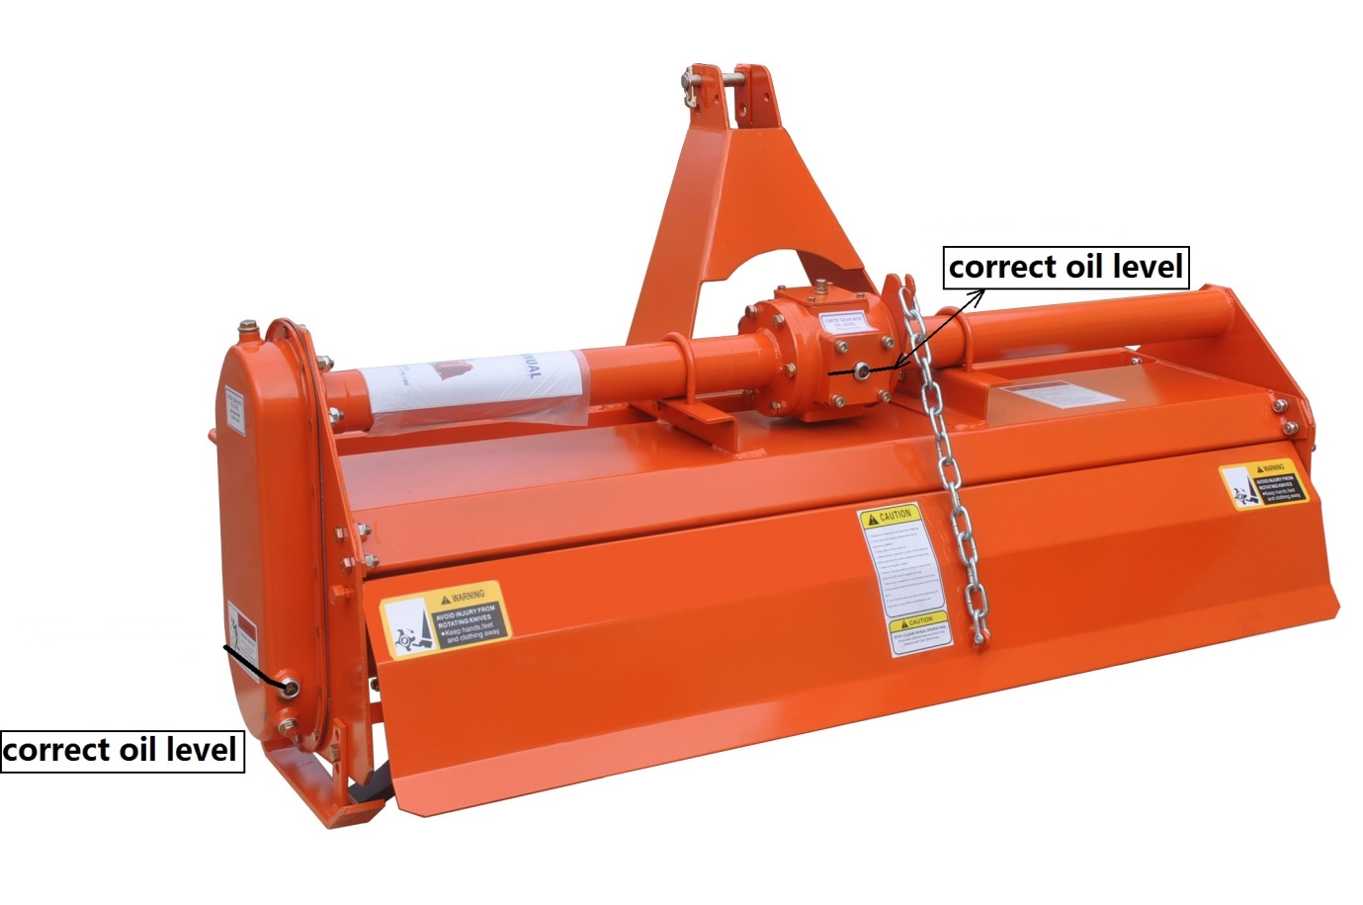

**Ryland Business Park, Bunclody, Co.Wexford**

**(053) 9376660 (087) 9186042**

**Safety information**

**Safety at all times**

**Throughly read and understand the instructions given in this manual before operation. Refer to the “Safety Decal”, read all instructions noted on them.**

* Operator should be familiar with all functions of the unit.
* Operate implement from the driver’s seat only.
* Make sure all guards and shiekds are in place and secured before operating the implement.
* Do not leave tractor or implement unattended with engine running.
* Dismounting from a moving tractor could cause serious injury or death.
* Do not stand between tractor and implement during hitching.
* Keep hands, feet, and clothing away from power-driven parts.
* Wear snug fitting clothing to avoid entanglement with moving parts.
* Watch out for wires, trees, etc., when raising implement. Make sure all persons are clear of working area.
* Turning tractor too tight may cause implement to ride up on wheels. This could result in injury or equipment damage.

**Be aware of signal words**

**A signal word designates a degree or level of hazard seriousness. The signal words are:**

**! DANGER**

Indicates an imminently hazardous situation which, if not avoids, will result in death or serious injury. This signal word is limited to the most extreme situations, typically for machine components that, for functional purpose, cannot be guarded.

**! WARNING**

Indicates a potentially hazardous situation which, if not avoided, could result in death or serious injury, and includes hazards that are exposed when grards are removed. It may also be used to alert against unsafe practices.

**! CAUTION**

Indicates a potentially hazardous situation which, if not avoided, may result in minor or moderate injury. It may also be used to alert against unsafe practices.

**For you protection**

* Thoroughly read and understand the “safety label” section, read all instructions noted on them.

Shtutdown and storage

* Lower machine to ground, put tractor in park, turn off engine, and remove the ignition key.
* Detach and store implements in a area where children normally do not play. Secure implement by using blocks and supports.

Use safety lights and devices

* Slow moving tractors, self-propelled equipment, and towed implements can create a hazard when driven on public roads. They are difficult to see, especially at night.
* Flashing warning lights and turn signals are recommended whenever driving on public roads.

**Transport machiery safely**

* Comply with state and local laws.
* Maximum transport speed for implement is 20 mph. Do not exceed. Never travel at a speed which does not allow adequate control of steering and stopping. Some rough terrain require a slower speed.
* Sudden braking can cause a towed load to swerve and upset. Reduce speed if towed load is not equipped with brakes.
* Do not tow a load that is more than double the weitht of tractor.

**Keep riders off machinery**

* Riders bostruct of operator’s view, they could be struck by forein objects or thrown from the machine.
* Never allow children to operate equipment.

**Practice safe maintenance**

* Understand procedure before doing work. Use proper tools and equipment.
* Work in a clean dry area.
* Lower the implement to the ground, put tractor in park, turn off engine, and remove key before performing maintenance.
* Allow implement to cool completely.
* Do not grease or oil implement while it is operation.
* Inspect all parts. Make sure parts are in good condition and installed properly.
* Remove buildup of grease, oil or debris.
* Remove all tools and unused parts from implement before operation.

**Prepare for emergencies**

* Be prepared if a fire starts.
* Keep a fist aid kit and fire extinguisher handy.
* Keep emergency numbers for doctor, ambulance, hospital and fire department near phone.

**Wear protective equipment**

* Protective clothing and equipment should be worn.
* Wear clothing and equipment appropriate for the job. Avoid loose fitting clothing.
* Prolonged exposure to loud noise can cause hearing impairment or hearing loss. Wear suitable hearing protection such as earmuffs or earplugs.
* Operating equipment safely requires the full attention of the operator. Avoid wearing radio headphones while operating machinery.

**Avoid high pressure fluids hazard**

* Escaping fluid under pressure can penetrate the skin causing serious injury.
* Avoid the hazard by relieving pressure before disconnecting hydraulic lines.
* Use a piece of paper or cardboard, not body parts, to check for suspected leaks. Wear protective gloves and safety glasses or goggles when working with hydraulic systems.
* If an accident occurs, see a doctor immediately. Any fluid injected into the skin must be treated within a few hours or gangrene may result.

**Structure and their adjustment**

These series rotary tillers are tillage equipment by means of the compound motion both of the rotation of the blade and the tractor going forward. Each rotary consists of transmission sets and working parts. Transmission sets include driveline, gearbox, side chain box (gearbox). Working parts include blade and blade shaft. Headstock, the cover and trailing bar are assistant sets (Fig.1).

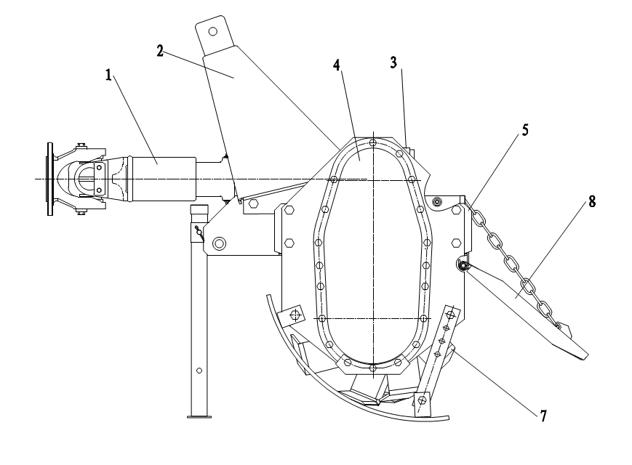

1-universal coupling 2-headstock 3-gearbox 4-side chain(gear)box 5.right side plate 6-cover 7-blade shaft 8-trailing bar

**Safety labels**



**Specification**

These series rotary tiller, are driven by the power-take –off of tractor. it is a kind of excellent equipment for primary and secondary tillage . it can match with 18.4-44.1kw(12-50HP)wheel-tractor, working on unplowed and plowed field , surface soil smooth ,good coverage with weed and stubble , working depth uniform , efficiency high . it can get the results of multi-ply plowing by one times tilling . it is suitable for plowing in dry field and paddy field in the area of producing wheat and rice .These series rotary tiller have 1GL105/125/135/150, 1GN180/200/230/250H, 1GKN180/200/230/250. Being adopted helical bevel gears meshing for main shift gears in the gearbox, whole structure , whole cover and forced trailing bar ,they are good rigidity , stable operation , low noise , high efficiency , low oil consume and easy to maintain ,etc. the ratio of breaking clod reaches above 95% .

**Technical parameter**

**RO medium series rotary tiller Side chain driven**

|  |  |  |  |  |  |  |  |  |
| --- | --- | --- | --- | --- | --- | --- | --- | --- |
| **Model** | **Working**  **width**  **(cm)** | **Blades shaft speed**  **(rpm)** | **Number of blades**  **( pcs )** | **Tilling depth**  **(cm)** | **Fitted power**  **(hp)** | **Net weight**  **(kg)** | **Gross weight**  **(kg)** | **Package size: (cm*cm*cm)** |
| **RO110** | **110** | **210** | **24** | **8-12** | **20-25** | **193** | **223** | **143*73*73** |
| **RO110** | **110** | **210** | **36** | **8-12** | **20-25** | **201** | **231** | **143*73*73** |
|  |  |  |  |  |  |  |  |  |
| **RO120** | **120** | **210** | **24** | **8-12** | **25-30** | **198** | **228** | **143*73*73** |
| **RO120** | **120** | **210** | **36** | **8-12** | **25-30** | **206** | **236** | **143*73*73** |
|  |  |  |  |  |  |  |  |  |
| **RO130** | **130** | **210** | **28** | **8-12** | **30-35** | **205** | **245** | **153*73*73** |
| **RO130** | **130** | **210** | **42** | **8-12** | **30-35** | **214** | **254** | **153*73*73** |
|  |  |  |  |  |  |  |  |  |
| **RO140** | **140** | **210** | **28** | **8-12** | **30-35** | **213** | **263** | **163*73*73** |
| **RO140** | **140** | **210** | **42** | **8-12** | **30-35** | **222** | **272** | **163*73*73** |
|  |  |  |  |  |  |  |  |  |
| **RO150** | **150** | **210** | **32** | **8-12** | **35-40** | **223** | **283** | **173*73*73** |
| **RO150** | **150** | **210** | **48** | **8-12** | **35-40** | **233** | **293** | **173*73*73** |
|  |  |  |  |  |  |  |  |  |
| **RO160** | **160** | **210** | **32** | **8-12** | **40-45** | **228** | **288** | **183*73*73** |
| **RO160** | **160** | **210** | **48** | **8-12** | **40-45** | **238** | **298** | **183*73*73** |
|  |  |  |  |  |  |  |  |  |
| **RO170** | **170** | **210** | **36** | **8-12** | **45-50** | **238** | **298** | **193*73*73** |
| **RO170** | **170** | **210** | **54** | **8-12** | **45-50** | **249** | **309** | **193*73*73** |
|  |  |  |  |  |  |  |  |  |
| **RO180** | **180** | **210** | **36** | **8-12** | **50-55** | **246** | **306** | **203*73*73** |
| **RO180** | **180** | **210** | **54** | **8-12** | **50-55** | **257** | **317** | **203*73*73** |

**Driveline assy**

The driveline consists of universal joint head, universal joint head for male shaft, the universal joint head for female shaft and joint cross. there are rings on the both ends of joint cross to avoid the movement of joint cross, and there is also a grease hole on the joint cross and the needle bearing can be well lubricated if you inject grease into it frequently. The universal joint head for male shaft and the universal joint head for female shaft are sliding joint and it can be pulled back and forth freely when the rotary tiller rises or falls. It must be noted that the interval between socket and shaft is in the shortest situation but the socket and the shaft can not contact each other during operating, and if the interval between the socket and the shaft is in the biggest situation, the overlap of socket and shaft must be longer or equal to the 1/2 length of the shaft.

**Headstock**

The upper hitch point on the headstock must be connected with the control link of the tractor and the lower coupling pin of headstock must be connected with the tension link of the tractor to make the rotary tiller form the stable three-point hitch linkage.

**Central gearbox assy**

The central gearbox assy consists of gearbox front cap, rear cap, first shaft, second shaft and a helical bevel gear pair that transmits the power to side chain box. There is an oil hole for adding oil on the top of the gearbox. And there is a plug for draining oil at the bottom of the gearbox. The helical bevel gear is splined matches the shaft .The gears are tightened with elastic collar, washer and locknut to prevent axial moving.

In using, the bearing clearance and the gear backlash will be changed because of wearing of bearings and gears, so you must adjust them (if necessary).

Adjustment of helical bevel gear backlash:

A proper backlash is the one of the condition for working normally. If the backlash is too large, it will result in the strong collision and loud noise.

Precaution:

Helical bevel gear backlash must be adjusted after the clearance of bearing on the first shaft has been adjusted. For retaining the clearance of bearing in which have been adjusted, for pinion, the total thickness of adjusted shims of the front and the hind bearing seat on the first shaft must keep up. For example, when moving the pinion forward, the decrease –the adjusted shims of the hind –bearing seat on the first shaft must be added to the front bearing seat on the first shaft, vice versa. For large helical bevel gear, when moving it rightward, you must decrease the shims of the bearing seat of the large bevel gear.

In general, just move the pinion forward when you do it.

Adjustment of the bearing axial clearance on the second shaft

When the axial displacement was occurred very distinctly on the second shaft, you must adjust it in time as following steps: first, loosen washer and screw down the lock nut, then adjusts the displacement of the bearing on the second shaft until there was no distinct axial movement and easy to rotate the shaft.

Finally, lock the jam nut with the washer. This prevents the bearing from loosing.

**Side chain(gear)box assy**

The side chain box consists of chain box, two chain wheels, chain tension units, second shaft and left side plate assy. Adjustment of the chain: Loosen and screw down the adjustable screw to adjust the tension of the chain, keep the right tension. In general, it can be pressed down 10 mm at another side of chain.

The side gearbox consists of side gearbox, three shafts and left side plate assy.

**Right side plate assy**

The right side plate assy consists of right side plate, right head of cultivator shaft, right side bearing and bearing seat.

**Cover assy**

A specific purpose of the cover is warding off clod, safeguarding the driver and still farther breaking the clod.

When rotary tiller is working, if the gap between the blade edge and the cover is too large ,the clod would be thrown to the front of the cultivator shaft, so that it will be cultivated once more, therefore the power of the tractor will be wasted; if the gap is too small, it is easy to congest, recommend gap is 30-45 mm.

**Cultivator shaft assy**

The cultivator shaft assy consists of cultivator shaft, blade disc and blade.

**Trailing bar**

The function of the trailing bar is still farther breaking the clod and flatting the cultivated land. It was connected with cover. You can obtain different effect of land surface by adjusting the height of the trailing bar. In general, if the soil is dry, to set lower, if the soil is wet, to set higher. When you remove the mud and the weed on the cultivator shaft, assemble the blades, long-distance transport; you should set the bar at the highest.

**Methods of operating**

**Installation of headstock with the main body**

Before being put in the container, the equipment is parted with the main body. The users refer to Fig.1,

simply to fix it on the main body with the bolts in the affix pouch. Pay attention to fitting the spring washers on the bolts, and fastening them firmly.

**The methods of blade mounting**

To meet the requirement of agricultural technique, the blades are adopted different fixing methods, so that a variety of tillage effects can be gotten. Blades should avoid mounting in reverse and making the back of the blades enter into soil, the parts will be damaged because of overload.

The left-bent blades and the right-bent blades work in a stagger state on whole blade shaft. Only a blade enters into soil at the same time. this arrangement is suitable to flat plowing, so the blade shaft operates stable; the surface of plowed field is smooth. To extend the application scope, every type of rotary tillers has tow sort of blade arrangement. Type 125and type 135 have 20 blades or 30 blades; type 150 has 24 blades or 36 blades, type 1780 has 28 blades or 42 blades. Please take a strictly attention to mounting the blades according to the mark on the blade discs.

**Connecting with the three-point linkage of tractor**

The connecting way of rotary tiller with the tractor is three-point linkage. The steps are as follows:

1. Align the center of headstock by reversing the tractor, raise the link arm to appropriate height, reverse the tractor to make the link arm of tractor joint with the left and right pin of rotary tiller.
2. first install the left lower linkage arm, then install right lower linkage arm, (because the leveling lift rod has screw that can be adjusted length.)finally insert the pins.
3. install the upper linkage arm, and then insert the pin.
4. mount the driveline, and then insert the pins, poke the cotter pin.

It must be taken attention to mounting order of the universal coupling.

**Adjustment before working**

**1. Adjustment of horizontal level**

Put it down to make the blade tips near the ground, observe that the height between the right and left blade tips and the ground is same or not. If not, it is necessary that the right linkage arm of tractor be adjusted to level off the blade shaft, which ensures the uniformity of working depth.

**2.Adjustment of longitudinal level**

Fall the tiller to tillage depth desired, observe that universal coupling and PTO shaft are level or not.

If the angle of universal coupling is too large, adjust the control link to make it nearly level, which can maintain that universal coupling and the tiller work in the good condition.

**Cultivating route**

When working in a piece of larger land, in land plowing is adopted to reduce the empty time in turn land, to raise work efficiency. The width of the plot selected is whole number multiple of the working width or near as possible, so as to decrease repeat tilling. The width of the plot is commonly 15m or so, if too wide, the empty time in turn land will be longer, the efficiency be less, the repeat times of idle motion be more, the mud depth be longer. The flat tillage in the medium and small fields refer to the in land plowing.

**Starting of the tiller**

First,filling with gear oil in the gearbox and the side chain box, injecting grease to the crosshead and the bearing seat of the blade shaft. Then check for the looseness of all connecting bolts and nuts, if loosing, fastening it at once. If the crack and deforming are found in the blades,they must be replaced.

Starting tractor: rise the tiller and the blade tip must be away from ground 150mm-200mm, and joint universal coupling, then run in 1-2 minutes, gear the operating gear position and increase the fuel throttle , control the leveling handle to make the tiller enter into the soil gradually until the normal tillage depth at the same time.

**Selecting of forward speed**

The selecting principle of tiller forward speed: the tractor cannot overload constantly; the performance of breaking soil meet the needs of agriculture requirement, furrow bottom and the soil surface are smooth. Not only be tillage quality ensured, but also the rated power of tractor be made good use of, and the purpose of rising work efficiency must be attained.

Generally, rotary tilling directly:2km/h-5km/h,harrowing:5km/h-7km/h;if the unit draft of the soil is bigger, can select lower gear; contrarily select higher gear; when working in dry fields, select lower gear; when working in paddy fields, select higher gear.

**Operating of headstock**

1. Using position control when the tiller works. The handle of draft control must be put in the position marked”up”.
2. When the handle of position control moves forward, the tiller fall down; contrarily the tiller rise.
3. After the tiller reaching to required depth, using the position hand-wheel to block it, in favor of that the tiller falls the same depth every time.
4. The details refer to the instruction of matching tractor.

**DRIVELINE DIMENSION**

A PTO driveline is supplied with the machine. To ac-company the variety of 3 point hitch geometry available today, the driveline can be too long for most machines or too short for others. It is very important that the drive- line be free to telescope but not to bottom out when going through its working range. If the driveline bottoms out, the bearings on both the machine and tractor PTO shaft will be overloaded and fail in a short time.

1. **To determine the proper length of the driveline, follow this procedure:**

a. Clear the area of bystanders, especially small children.

b. Attach the chipper to the tractor (see section), but do not attach the driveline.

c. Raise the machine until the input shaft is level with the tractor PTO shaft.

d. Measure the dimension between the locking grooves on the tractor PTO shaft and the machine input shaft.

e. Measure the same dimensions on the compressed driveline.

f. If the compressed driveline dimension exceeds the machine dimension, the driveline will have to be cut.

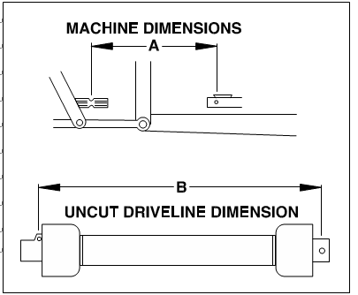

2. **When cutting the driveline, follow this procedure:**

a. Subtract the machine dimension (A) from the uncut driveline dimension (B) or (B-A). This dimension determines how much too long the driveline is.

b. Add another inch (25 mm) to the dimension to be sure it doesn't bottom out, to determine (C) the cut off dimension.

c. Use a hacksaw to cut dimension (C) from both ends. Cut both the plastic tubes and the metal cores.

d. Use a file to remove the burrs from the edges that were cut.

e. Assemble the 2 ends of the shaft.

f. Make sure the shaft can telescope freely. If it does not, separate the 2 parts and inspect for burrs or cuttings on the shaft ends. Be sure it telescopes freely before installing.

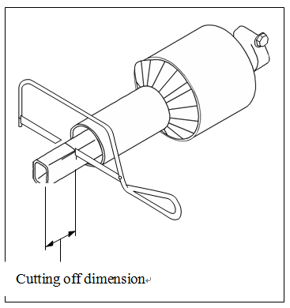

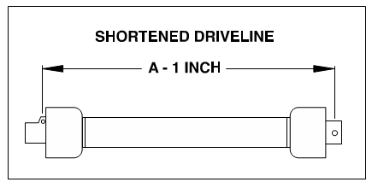

**Maintenance**

To ensure that the tiller woks properly, higher efficiency and prolonging the serve life, it is important that maintenance must be done properly.

**Daily maintenance (after 10 hours operating)**

1. Check, tighten up all of the joint bolts and nuts, tighten them up or replace them if necessary.
2. Check the lubricant oil in the gearbox and the side chain (gear) box, keep the oil level desired.
3. Check universal joint cross, pin, grease cup on the bearing seat, inject grease into the cup.
4. Check the blades to see if the blades are disable and their fasten bolts are loose, should replace or tighten them if necessary.
5. Check the tension of chain; adjust it if necessary.

**Season maintenance (after one season operating)**

**Besides performing the proceeding of daily maintenance, the following must be done also:**

1. Replace lubricating oil. It can be done in advance or delayed if necessary.
2. Check universal joint cross. If it is seriously worm, replace it.
3. Check the bearings in the both ends of the blade shaft to see if turbid water enter it because of the faults of oil seals. Disassemble it to clean, replace the oil seals and inject enough grease.
4. Check all bearings; adjust or replace them if necessary.
5. Check helical bevel gears; adjust them if necessary.

**Yearly maintenance (after one year operating)**

1. Remove all dust and filth away from the tiller.
2. Drain out gear oil and disassemble the tiller to check on. If bearings be worn seriously or go wrong, it must be replaced; the parts must be cleaned before assembled. Final, add new oil to standard oil level.
3. Disassemble and clean the bearings and their seat of blade shaft, replace the oil seals and inject enough grease.
4. Disassemble and clean the universal joint cross assembly, and clean the roller pins of the universal joint, replace them if necessary.
5. Check the fastener and the cotter pins, etc. If the part is rusty or worn seriously, or the disable, it must be replaced.
6. Check the blades to see if there is crack, wear and tear on them, or loss. It must be replaced or added if necessary.
7. Check the blade holder, replace or repair them if necessary.
8. Repair the cover and the trailing bar.
9. The rotary tiller must be placed indoor as possible during it parks, and be raised to make the blade tips leave the ground. The blades and processing surface revealed must smeared oil to prevent from rusty. The surface in which the paint broken off must be painted with the primitive colors to prevent from rusty.

**Lubrication sites**

|  |  |
| --- | --- |
| Lubrication sites | Purpose |
| Oil check screw plug | Check the oil level of the gearbox and the side chain (gear) box (injection should continue until oil overflows out from the oil check hole). |
| Ventilate screw plug | Ventilation of the side chain (gear)box |
| Grease cup of the joint cross | Inject the grease into the joint cross (so that lubricate the roller needle  Of the joint cross) |
| Grease cup of the bearing seal on the cultivator shaft | Inject the grease into the bearing and the oil seals of the cultivator Shaft(lubricate the bearings and the oil seals) |

**WARRANTY POLICY**

Danso Machinery Ltd. warrants to the original purchaser (owner) of each new Danso product, that it will repair or replace, without charge for labour or parts, any defective or malfunctioning parts in accordance with the warranty limitations and adjustments schedule below.

**PRODUCT – ALL**

**PRIVATE DOMESTIC USE – 12 MONTHS**

**PRIVATE and COMMERCIAL AGRICULTURAL USE – 12 MONTHS**

**AGRICULTURAL CONTRACTORS – 6 MONTHS**

**GOVERNMENT and MUNICIPAL DEPARTMENTS – 6 MONTHS**

**ALL OTHER NON-AGRICULTURAL APPLICATIONS – 3 MONTHS**

**HIRE COMPANIES – 3 MONTHS**

The warranty period will begin on the date the product is delivered to the first retail purchaser.

**THIS WARRANTY COVERS:**

* Claims resulting from defects in workmanship or material under normal use and service.

**THIS WARRANTY DOES NOT COVER:**

* Conditions resulting from misuse, negligence, alteration, accidental damage or failure to perform normal maintenance services;
  + Any product which has been repaired by other than an authorised Danso Machinery Ltd. service outlet so as, in any way in the sole and absolute judgement of Danso Machinery Ltd., to affect adversely its performance and reliability;
  + The replacement of wear and tear items such as diaphragms, V belts and ground engaging components;
  + Loss of time, inconvenience, loss of use of the product or any other consequential damages.

The repair of defective products qualifying under this warranty will be performed by an authorised Danso Machinery Ltd. service outlet within a reasonable time following the delivery of the product, at the cost of the owner, to the service outlet’s place of business. The product will be repaired or replaced, using new parts sold by Danso Machinery Ltd.

The owner is responsible for the performance of regular maintenance services as specified in the Operator’s Manual applicable to the product.

* **THIS WARRANTY IS THE ONLY WARRANTY APPLICABLE TO DANSO MACHINERY LTD. NEW PRODUCTS AND, TO THE MAXIMUM EXTENT PERMITTED BY LAW, IS EXPRESSLY IN LIEU OF ANY OTHER WARRANTIES EXPRESSED OR IMPLIED, INCLUDING ANY IMPLIED WARRANTY OF MERCHANTABILITY OR FITNESS FOR A PARTICULAR PURPOSE.**
* **DANSO MACHINERY LTD. DOES NOT AUTHORISE ANY PERSON TO**

**CREATE FOR IT ANY OTHER OBLIGATION OR LIABILITY IN CONNECTION WITH THESE PRODUCTS.**

* **SUBJECT ONLY TO LEGISLATIVE OBLIGATIONS TO THE CONTRARY. DANSO MACHINERY LTD. SHALL NOT BE LIABLE FOR INCIDENTAL OR CONSEQUENTIAL DAMAGES RESULTING FROM A PRODUCT PERFORMING IN BREACH OF THIS WRITTEN WARRANTY.**

**ABOUT YOUR WARRANTY**

Danso Machinery Ltd. welcomes any genuine warranty repair. The following information will assist your understanding of warranty procedures.

Any authorised Danso dealer service outlet can perform warranty repairs for you, however, we recommend that such repairs be carried out by the Dealer from whom you bought the product.

Most warranty repairs are handled routinely, but sometimes requests cannot be accepted under warranty. Normal wear and tear is not covered by warranty nor does warranty apply if a product failure can be attributed to abuse or neglect.

Whilst Danso Machinery Ltd. will abide by its warranty policy under all genuine circumstances, we must emphasise that such can only apply when our equipment has been used in applications for which it was designed and manufactured and that a reasonable degree of care and common sense has been exercised by the operator.

To avoid misunderstandings, which might occur between the customer and the service outlet, items subject to normal wear and tear such as mechanical seals and similar items are not covered under warranty.

**Warranty Repair Site**

The warranty provides for repairs to be carried out at the servicing dealer’s normal place of business. An owner may elect to have repairs carried out at his own residence but, whilst Danso Machinery Ltd. will accept the actual repair cost of the failed component(s), the travelling costs will not be covered under warranty - see following.

**Items Not Covered By Warranty**

The warranty does not allow for the cost of the following items. These are the responsibility of the owner.

1. Labour to travel to and from a broken-down product or for any distance charges.
2. Labour premiums that might apply for any repairs that are made outside the dealer’s normal business hours.
3. Transportation costs of the machine to and from the service outlet.
4. Freight costs to get parts to and from the service outlet.
5. All communication costs made by the owner in connection with the warranty repair.

**Trouble shouting**

|  |  |  |
| --- | --- | --- |
| Problem | Cause | Solution |
| Universal coupling inclined too much | Rotary tiller failed horizontal  Level | Adjust the horizontal level of The tiller |
| One side sway chain of tractor is too short | Adjust the chain |
| Universal coupling injured | Direction mistaken | Re-assemble correctly |
| Grease deficient | Rinse neeble and inject grease  Sufficiently |
| Angle of universal coupling is  Too big or is gripped | Limit the rising position and re-lock the position |
| Rotary tiller fallen down the  soil sharply | Fall the tiller down the soil  Smoothly |
| Noise in gearbox | The clearance between the two  Helical bevel gears is too large | Adjust this clearance |
| Bearing injured | Replace bearing |
| Tooth of gear broken | Replace gear |
| Noise in side chain box (type RO) | Foreign matter dropper in  chain box | Take foreign matter out of the  Chain box |
| The tension of chain is too lax | Adjust the tension of chain |
| Chain and chain wheel excessive wear | Replace chain and chain wheel |
| Bearing on the third shaft injured | Replace bearing |
| Noise in side chain box (type RO) | Foreign matter dropped in chain box | Take foreign matter out of the chain box |
| Bearing on the third shaft injured | Replace bearing |
| Bearing on the middle shaft injured | Replace bearing |
| Trouble rotation of cultivator shaft | Gear or bearing injured or gripped | Replace gear or bearing |
| There was no clearance between the two helical bevel gears | Adjust the clearance of the helical bevel  gear pair |
| Out of shape of left side plane | Correct side plane |
| Cultivator shaft crooked or out  of shape | Correct or replace cultivator shaft |
| Cultivator shaft crooked or out of shape | Clear away grass or soil |
| Blade slot injured | Cultivator shaft twined with grass or hold soil seriously | Clear away the stone from the field |
| Blade run foul of stone so that it suffers too much force | Assemble the blades correctly |
| Blade assembled on opposite direction so that it suffers too much force | Fall the tiller down the soil smoothly |
| Blades crooked or broken | Rotary tiller fallen down the soil sharply so that it suffers too much force | Replace the blades and clear away  The stones from the field |
| Blades run foul of stone | Rise the tiller and do not plough when the tractor turns a corner in the field |
| Doing plough when tractor turns a corner in the field | Fall the tiller down smoothly |

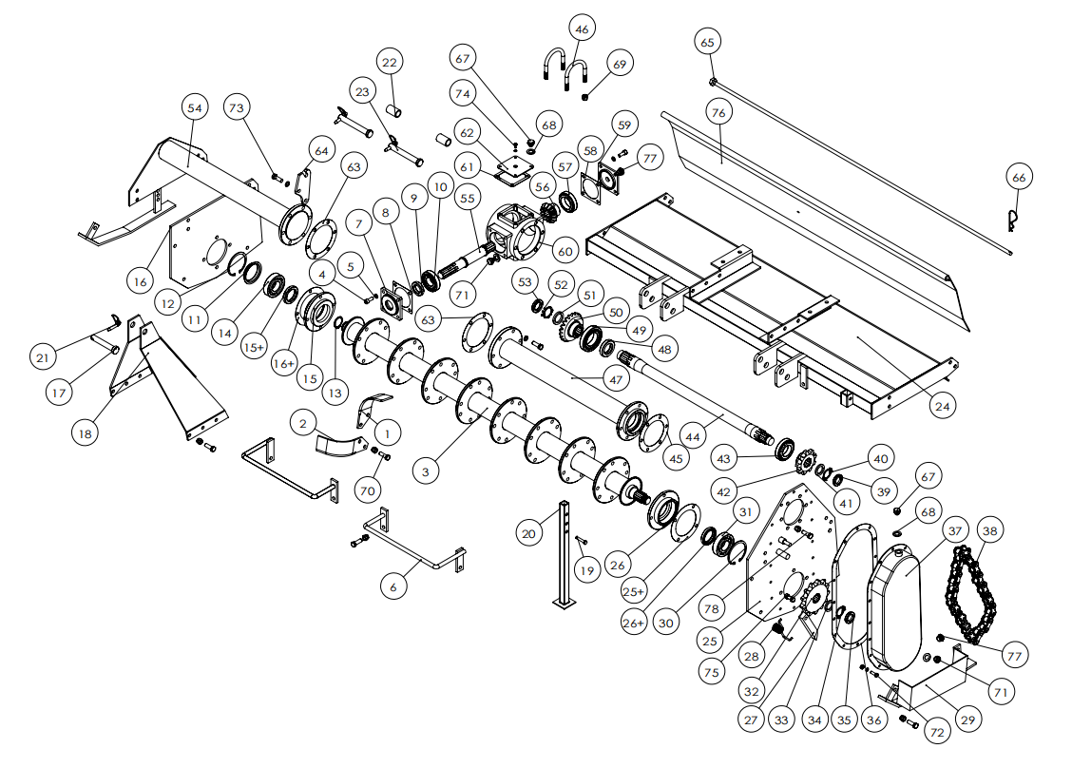

|  |  |  |  |  |  |  |
| --- | --- | --- | --- | --- | --- | --- |
| Ser. No. | Name | Qty |  | Ser. No | Name | Qty |
| 1 | Left-bent blade | 16 | 38 | Chain | 1 |
| 2 | Right-bent blade | 16 | 39 | Circular nut | 1 |
| 3 | Blade shaft | 1 | 40 | Stop washer | 1 |
| 4 | Bolts | 8 | 41 | Washer | 1 |
| 5 | Spring washer | 8 | 42 | Small sprocket wheel | 1 |
| 6 | Protective guard | 2 | 43 | Bearing | 1 |
| 7 | Cap | 1 | 44 | Second shaft | 1 |
| 8 | Oil seal ring | 2 | 45 | Oil seal ring | 1 |
| 9 | Oil seal | 1 | 46 | U-bolts | 2 |
| 10 | Bearing | 1 | 47 | Main frame pipe | 1 |
| 11 | cover | 1 | 48 | Oil seal | 1 |
| 12 | Eyelet washer | 1 | 49 | Bearing | 1 |
| 13 | Shaft washer | 1 | 50 | Big bevel gear | 1 |
| 14 | Bearing | 2 | 51 | Washer | 1 |
| 15 | Bearing seat | 1 | 52 | Stop washer | 1 |
| 15+ | Oil seal of bearing seat | 1 | 53 | Circular nut | 1 |
| 16 | Side board | 1 | 54 | Auxiliary frame pipe | 1 |
| 16+ | Oil seal ring of bearing seat | 1 | 55 | First shaft | 1 |
| 17 | Pin | 1 | 56 | Small bevel gear | 1 |
| 18 | Shield protective cover | 1 | 57 | Bearing | 1 |
| 19 | Pin | 1 | 58 | Oil seal ring | 1 |
| 20 | Stay bar | 1 | 59 | Cap | 1 |
| 21 | Pin | 3 | 60 | Intermediate gearbox | 1 |
| 22 | Sheath | 2 | 61 | Oil seal ring | 1 |
| 23 | Pin | 2 | 62 | Cap | 1 |
| 24 | Cover | 1 | 63 | Oil seal ring | 2 |
| 25 | Side board | 1 | 64 | Suspension Slice | 1 |
| 25+ | Oil seal ring of bearing seat | 1 | 65 | Rod | 1 |
| 26 | Bearing seat | 1 | 66 | B type pin | 1 |
| 26+ | Oil seal of bearing seat | 1 | 67 | Venting oil plug | 2 |
| 27 | Tension plate | 1 | 68 | Copper gasket | 2 |
| 28 | Spring | 1 | 69 | M12 locknut | 1 |
| 29 | Anti-friction plate | 2 | 70 | M12*30 bolt+locknut |  |
| 30 | Eyelet washer | 1 | 71 | Oil drain plug | 2 |
| 31 | Bearing | 1 | 72 | M8*25 bolt + nut  + spring washer | 16 |
| 32 | Big sprocket wheel | 1 | 73 | M12*35 bolt + spring washer | 12 |
| 33 | Washer | 1 | 74 | M6*10 bolt + spring washer | 4 |
| 34 | Stop washer | 1 | 75 | M10*35 bolt + nut  + bonded washer | 8 |
| 35 | Circular nut | 1 |  | 76 | Tail plate | 1 |
| 36 | Oil seal ring | 1 |  | 77 | oil check plug | 2 |
| 37 | Side chain box | 1 |  | 78 | Bolt+locknut | 6 |

